Naming Organisms using a classification system
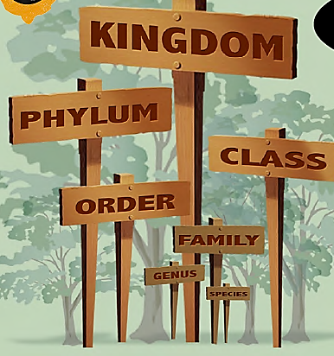
A Swedish biologist Carl Linnaeus (1707-1778) was the person most responsible for the classification system we use today. He devised a hierarchical system with seven different classification levels:
KINGDOM, PHYLUM, CLASS, ORDER, FAMILY, GENUS, and SPECIES.
The last two classifying levels (Genus and Species) are used to name each organism. This meant he created a unique classifying and naming system for each organism on Earth… not a bad effort!
All the organisms in the SPECIES level of classification are able to breed with other individuals in the same SPECIES. This is true even when individuals appear to be very different, such as in some domesticated species such as cattle, dogs and cats. Individuals from different species are not able to interbreed.

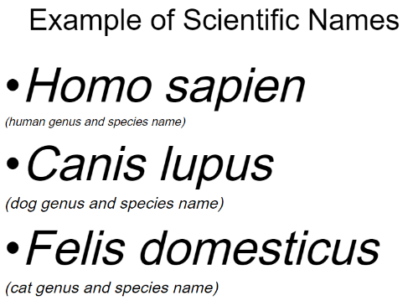
Under the Linnaeus system every living organism is given a unique, binomial (two-part) scientific name. Some simple rules to follow when writing a scientific name are
- The whole name is written in italics
- The first part is the genus name and is written with a capital letter at the start.
- The second part is the species name and is written all in lower case.

